W2 - OS Lab Work

1WA24CS241

- Algorithm FCFS
Input: List of processes with (ProcessID, ArrivalTime, BurstTime)
Output: CompletionTime, TurnaroundTime, WaitingTime for each process

Code >>>
#include <stdio.h>

int main() {
int n;
int at[20];
int bt[20];
int wt[20];
int tat[20];
float twt = 0.0;
float ttat = 0.0;
float awt;
float atat;

printf("Stawan H. Ruiwale, 1WA24CS241\n\n");

printf("Enter the num of process : ");
scanf("%d", &n);

printf("Enter the arrival time for each process: ");
for (int i = 0; i < n; i++) {
printf("Process %d Arrival time : ", i + 1);
scanf("%d", &at[i]);
}

printf("Enter the burst time for each process: ");
for (int i = 0; i < n; i++) {
printf("Process %d Burst time : ", i + 1);
scanf("%d", &bt[i]);
}

// Calc wt and tat
wt[0] = 0; //doesn't wait
tat[0] = bt[0]; //tat for the 1st process is its bt
for (int i = 1; i < n; i++) {
//wt of current process = wt of previous process + bt of previous process
wt[i] = wt[i - 1] + bt[i - 1];
// tat = wt + bt
tat[i] = wt[i] + bt[i];
}

// Calc total and avg times
for (int i = 0; i < n; i++) {
twt += wt[i];
ttat += tat[i];
}
awt = twt / n;
atat = ttat / n;

// Display results
printf("\nProcess\tBurst Time\tWaiting Time\tTurnaround Time\n");
for (int i = 0; i < n; i++) {
printf("P%d\t%d\t\t%d\t\t%d\n", i + 1, bt[i], wt[i], tat[i]);
}

printf("\nAverage Waiting Time: %.2f\n", awt);
printf("Average Turnaround Time: %.2f\n", atat);

return 0;
}

Output
>>>
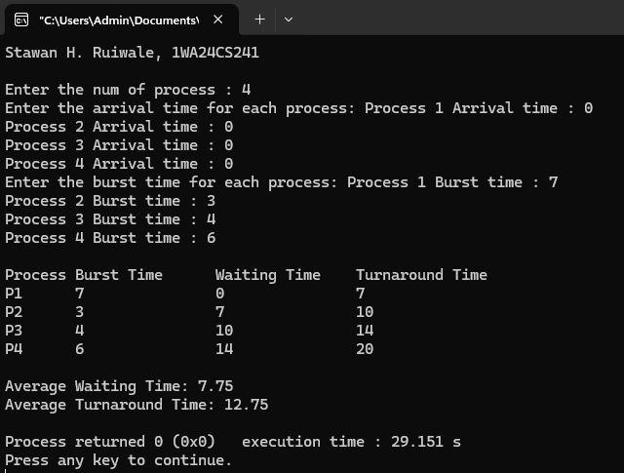
- Algorithm SJF_NonPreemptive :

Code
>>>
#include <stdio.h>

int main() {
int n, i, j;
int pid[20], at[20], bt[20], ct[20], tat[20], wt[20];
int completed[20] = {0};
int current_time = 0, completed_count = 0;
int min_bt, index;

printf("Stawan H. Ruiwale, 1WA24CS241\n\n");

printf("Enter number of processes: ");
scanf("%d", &n);

for(i = 0; i < n; i++) {
printf("Enter Arrival Time and Burst Time for P%d: ", i+1);
scanf("%d %d", &at[i], &bt[i]);
pid[i] = i + 1;
}

while(completed_count < n) {
min_bt = 9999;
index = -1;

for(i = 0; i < n; i++) {
if(at[i] <= current_time && completed[i] == 0) {
if(bt[i] < min_bt) {
min_bt = bt[i];
index = i;
}
}
}

if(index == -1) {
current_time++;
} else {
ct[index] = current_time + bt[index];
tat[index] = ct[index] - at[index];
wt[index] = tat[index] - bt[index];

current_time = ct[index];
completed[index] = 1;
completed_count++;
}
}

printf("\nPID\tAT\tBT\tCT\tTAT\tWT\n");
for(i = 0; i < n; i++) {
printf("P%d\t%d\t%d\t%d\t%d\t%d\n",
pid[i], at[i], bt[i], ct[i], tat[i], wt[i]);
}

return 0;
}

Output
>>>
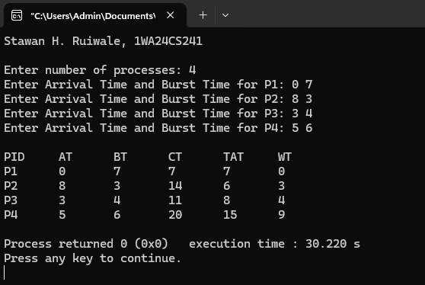

- Algorithm SJF Preemptive :

Code
>>>
#include <stdio.h>

int main() {
int n, i;
int pid[20], at[20], bt[20], rt[20];
int ct[20], tat[20], wt[20];
int completed = 0, current_time = 0;
int min_index, min_rt;

printf("Stawan H. Ruiwale, 1WA24CS241\n\n");

printf("Enter number of processes: ");
scanf("%d", &n);

for(i = 0; i < n; i++) {
printf("Enter Arrival Time and Burst Time for P%d: ", i+1);
scanf("%d %d", &at[i], &bt[i]);

pid[i] = i + 1;
rt[i] = bt[i];
}

while(completed < n) {
min_rt = 9999;
min_index = -1;

for(i = 0; i < n; i++) {
if(at[i] <= current_time && rt[i] > 0) {
if(rt[i] < min_rt) {
min_rt = rt[i];
min_index = i;
}
}
}

if(min_index == -1) {
current_time++;
} else {
rt[min_index]--;
current_time++;

if(rt[min_index] == 0) {
completed++;

ct[min_index] = current_time;
tat[min_index] = ct[min_index] - at[min_index];
wt[min_index] = tat[min_index] - bt[min_index];
}
}
}

printf("\nPID\tAT\tBT\tCT\tTAT\tWT\n");
for(i = 0; i < n; i++) {
printf("P%d\t%d\t%d\t%d\t%d\t%d\n",
pid[i], at[i], bt[i], ct[i], tat[i], wt[i]);
}

return 0;
}

Output
>>>
